**Progress Report to the Open Data Governance Board**

JUNE 2025 – Quarterly Update  
Completed by Open Data Unit, Public Service Transformation Division, DPENDR

1. **Progress since last meeting**

**1.1 Highlights**

**Portal Update:**

The Open Data Unit has received approval for two short-term projects: a superset configuration and an accordion-style FAQ page. The accordion-style FAQ page for the portal will allow the team to track the most sought-after answers from the page. The Superset feature for the portal will allow for data analysis and visualisation, allowing users to connect to various datasets on the portal and provide a wide range of visualisation options for creating reports.

1. **Implementation plan for Open Data Strategy** – **see separate excel tracker**

Portal statistics – reports generated from the portal

* + 21072 Datasets published
  + 143 publishers
  + 22,051 visits

**Open data queries tracker report**

Open Data Tracker:

* Since the creation of the tracker we have now closed out on over 4671 queries.
* In 2025, so far, we have had 224 tickets.
* In quarter one of 2025, 147 of these tickets were opened in comparison to quarter one 2024s 224.
* Most of the queries were dataset requests.
* 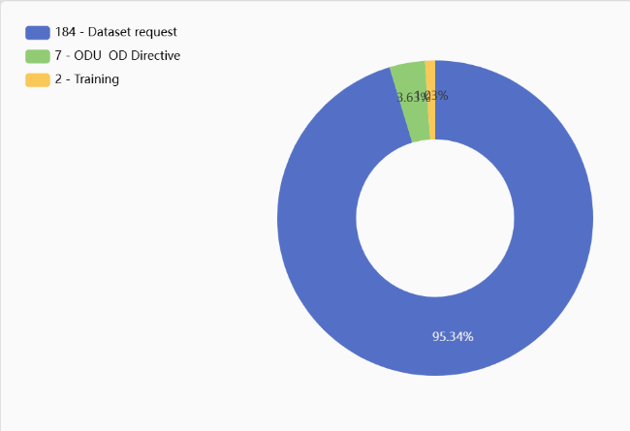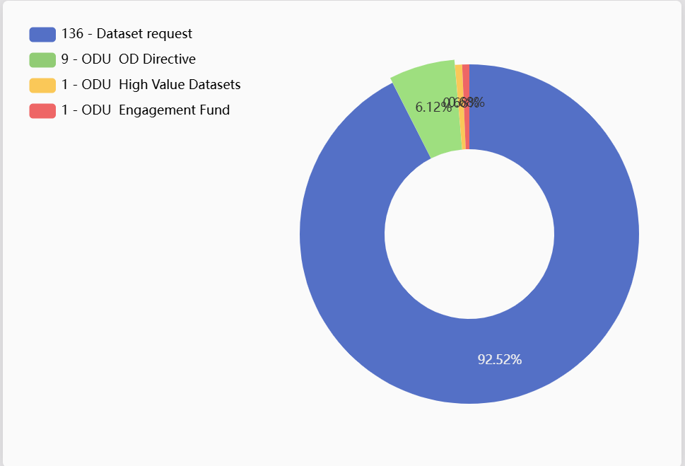

2025 2024

**Data.gov.ie Publisher and User Rationalisation**

The Open Data Unit has audited all members associated with publisher accounts on the portal. As a result, actions were taken to cancel any unnecessary access. All remaining portal members have been verified to be associated with their work email address. We have also reviewed all publishers enrolled on the portal. Throughout this process, we have cleaned and removed inactive publishers who have ceased to exist or have been amalgamated into a larger organisation. This review has ensured our list of publishers is current and up to date. For publishers at the initial stages of their open data journey, we are actively pursuing and following up with them, offering the advice and support they need. We are also taking the initiative to remind them of our expectations at national and EU levels.

**Open Data Communications**

## Newsletter:

In April 2025, our first Open Data Newsletter of the year was sent out to 1885 recipients on our subscribers list. This newsletter featured articles on:

* Ireland's continued excellence in the Open Data Maturity Report
* National Companies Registration Data as Open Data
* The Green and Social Hours initiative
* Smart Dublin's Award for their Active Travel Open Data Dashboard
* Open Data Training

The newsletter was sent out using Mail Chimp and the Open Data Unit have been able to track engagement.

* This newsletter had an Open Rate of 40%, which is a decrease of the previous newsletter at 60.2%. Through trial and error, it now looks like sending the newsletter later in the day, instead of the morning time yields a higher open rate. This is something we will factor in next time.
* Our Click Rate was slightly lower than the last newsletter at 10.3% dropping from 11.5%
* The top links clicked within the newsletter were the data.gov.ie site, the article on the ODM survey as well as Open Data Training.

The April newsletter can be viewed here at: <https://mailchi.mp/597568a2a5a8/open-data-updates-12816356>

Our next Newsletter is due to go out in late June/ early July. This newsletter will thus far feature articles on

* The Companies' Registration Office and their HVD compliance
* The Open Data Unit's attendance at EU Open Data Days
* The Open Data Unit's attendance at the 36th Meeting of the Public Sector Information (PSI) Expert Group in Luxembourg.
* Open Data Training for the Autumn

## Open Data Training:

In order to address the low uptake in Open Data Training as mentioned in the previous Risk Register, the Open Data Unit ran a successful communications and marketing campaign. The Open Data Unit worked with the Department's Communications team to design an awareness poster about Open Data Training. We circulated this to all ODLOs, and tapped into various new networks such as all L&D teams within departments. This led to a dramatic increase in training with no courses cancelled, as they had been previously.

The current training framework will expire at the end of 2025 and the ODU are research alternative training delivery models.

**New Public Sector Data Strategy 2030**

The Open Data Unit as part of a cross departmental working group in DPENDR has been developing the next iteration of the Public Sector Data Strategy 2030. We have been working to ensure that the public sector data strategy aligns in parallel to the Open Data Strategy on enhancing the accessibility and quality of data across the public sector. In essence, the new Public Sector Data Strategy 2030 aims to foster a data driven culture within the public service, promoting transparency, innovation, and improved public services.

**Open Data Maturity Survey 2025:**

The Open Data Unit have submitted the first draft of the Open Data Maturity Survey 2025. The deadline for the first draft of the survey was the 14th of May. There will be an option to review/clarify answers in early autumn.

1. **Risk Register:**

* The majority of activity items in the attached tracker are going as planned and are on schedule.
* As mentioned previously, there is no 2025 Open Data Engagement Fund. This may impact the communications we have with our network and Ireland’s ranking of Open Data maturity in the EU. There will be a more detailed presentation on this further down the agenda.